**Mini-Project 1**

**cellular EP modelling**

MSB1007

Mai Lê (i6375777)

Ayesha Qayyum (i6267211)

Sem Verstappen (i6294976)

Siem Vonk (i6290798)

# Introduction

Brugada syndrome (BS) is a genetic disorder affecting 0.05% of the world’s population [1]. It is defined as a channelopathy and marked by conduction abnormalities which increase the risk of ventricular arrhythmias. In the clinic, this is marked by ST segment irregularities in leads V1-V3 on an electrocardiogram. BS typically leads to ventricular arrhythmias that predispose to sudden cardiac death. The syndrome is primarily inherited in an autosomal dominant manner and molecular diagnosis is confirmed by identifying a pathogenic variant in *SCN5A* or one of 42 associated genes [2]. The *SCN5A* gene encodes the α-subunit of the sodium channel, and over 100 *SCN5A* mutations have been linked to BS. In BS, a loss of function of sodium channels results in impaired phase 0 depolarization and a slowed cardiac conduction. A wide array of factors lead to the loss of function, such as the production of nonfunctional channels or altered gating properties, including delayed activation, faster inactivation, and impaired recovery from inactivation [3]. Currently, the only treatment available is the implantation of cardioverter defibrillators, however, these are invasive and accompanied by many risks [4]. Computational models serve as powerful tools for simulating and better understanding the mechanisms underlying BS, enabling rapid *in silico* experiments with complete control and observation.

# Methodology

The Myokit implementation of an epicardial ventricular canine myocyte described by Decker *et al.* was used as a foundation for the conducted simulations [5].The model definition for INa was adjusted from the original Hodgkin-Huxley approach into the wildtype Markov model described by Clancy *et al.* to be able to simulate the Na+ channel behavior in more detail [6]. The Markov model is composed of nine states, including one open state, three closed states, and five inactivated states. Transitions between these states are controlled by transition rates whose equations include all parameters required for simulation procedure. Experimental voltage-clamp protocols for activation, inactivation and recovery from inactivation referenced from Zeng *et al.*’s study [7] were implemented to estimate parameter sets for both wild-type (WT) and mutant (MT) phenotypes. Parameter optimization was performed using Nelder-Mead optimization to fit the model simulations of activation, inactivation and recovery from inactivation to the experimental data for both WT and MT. All parameters in the rates for the ordinary differential equations for INa were included for optimization. For the WT, 100 iterations were performed, while for MT conditions, 250 iterations were performed. Finally, the adjusted model containing the optimized parameter values was used to generate action potentials (APs) to compare the AP between the WT and MT in the model. Different pacing rates of 1000, 750, and 300 ms were applied with 30.000 ms of pre-running before measurement.

# Results

Parameter optimization in the model to fit experimental data for both WT and MT phenotype resulted in moderate quality fits (Fig 1). Activation contributed to the largest error in both WT (Fig 1A) and MT (Fig 1D) with an error of 0.172 and 0.133 respectively. The second largest error for both was inactivation with 0.069 for WT (Fig 1B) and 0.113 for MT (Fig 1E). The smallest error in both was the fit for recovery from inactivation, which was 0.034 in the WT (Fig 1C) and 0.075 in the MT (Fig 1F). The sum of the errors from the individual protocols results in an error of 0.275 for WT and 0.322 for MT. APs show clear differences between the two phenotypes (Fig 2). At a pacing rate of 1000 ms, the peak reaches lower peak voltage and reaches the highest point after the initial depolarization (Fig 2A). Similar AP differences can be seen at a pacing of 750 ms, but the initial peak and repolarization seem to be even less pronounced (Fig 2B). At a pacing rate of 300 ms, APs similar to the ones in slower rates are followed by failed APs, not reaching the depolarization thresholds in the MT (Fig 2C).

# Discussion

The initial differences between the APs in WT and MT can be seen in the reduced peak height of the MT and the reduced phase 1 repolarization. The reduced peak indicates a reduction in sodium current which is associated with BS. The alternating pattern between altered APs and failed APs with a loss of dome at a pacing rate of 300 ms in the MT is similar to what is seen in the epicardial cell simulations of Clancy and Rudy [6]. However, at 300 ms, WT APs look similar to the AP seen in the MT, but WT APs are consistently the same, with no failing depolarizations. Recovery from inactivation at 300 ms in the WT is not fast enough to cause a normal AP as seen at slower pacing rates.

The mutation underlying BS results in a reduced Na+ current, the resulting reduced INa is anticipated to lead to the suppression of the AP plateau in cells with significant Ito, such as those found in the right ventricular epicardium [8,9]. At these faster pacing rates, this phenotype is more pronounced in the model and loss of dome in specifically epicardial cells is associated with BS and ST-segment elevation. Similar to the simulations of Clancy and Rudy [6], 1000 and 750 ms rates do not result in any failed APs in our model, but MT APs are slightly longer and domes are more substantial in our model as well.

The Decker *et al.* model represents a cardiomyocyte epicardium of a canine ventricle. This model has similar behaviour of ion channels as in human ventricular cells, except for the density of IK1 which is larger four-fold than human myocytes and Ito recovery kinetics which displays difference in time course between these species [10]. Therefore, a stronger repolarization phase was observed in our AP curves compared to that of humans.

Parameter optimization of the model could possibly be improved by weighing the activation protocol fits more compared to the other fits, as this accounted for the largest error in both phenotypes. The parameter sets chosen in this study are not very accurately representing the experimental data. Parameters that more closely simulate the properties seen in experimental data could provide better insight into differences in action potentials. While the model includes all ion channels, the parameter optimization for WT and MT conditions specifically affected Na+ channels to model the mutation associated with BS. Although this approach successfully captured key differences in AP, such as reduced peak voltage and loss of phase 1 repolarization, it does not account for potential secondary effects on other ion channels that may arise from the Na+ channel mutation. Moreover, to comprehensively understand cardiac electrophysiology, a multi-scale model combining subcellular, cellular, tissue, and organ levels should be implemented in future studies.

In conclusion, the mutant model exhibited reduced AP peak voltage, loss of phase 1 early repolarization, and alternation between failed and hampered APs at faster pacing rates, consistent with BS. These findings emphasize the role of reduced sodium current in AP rates and shapes.

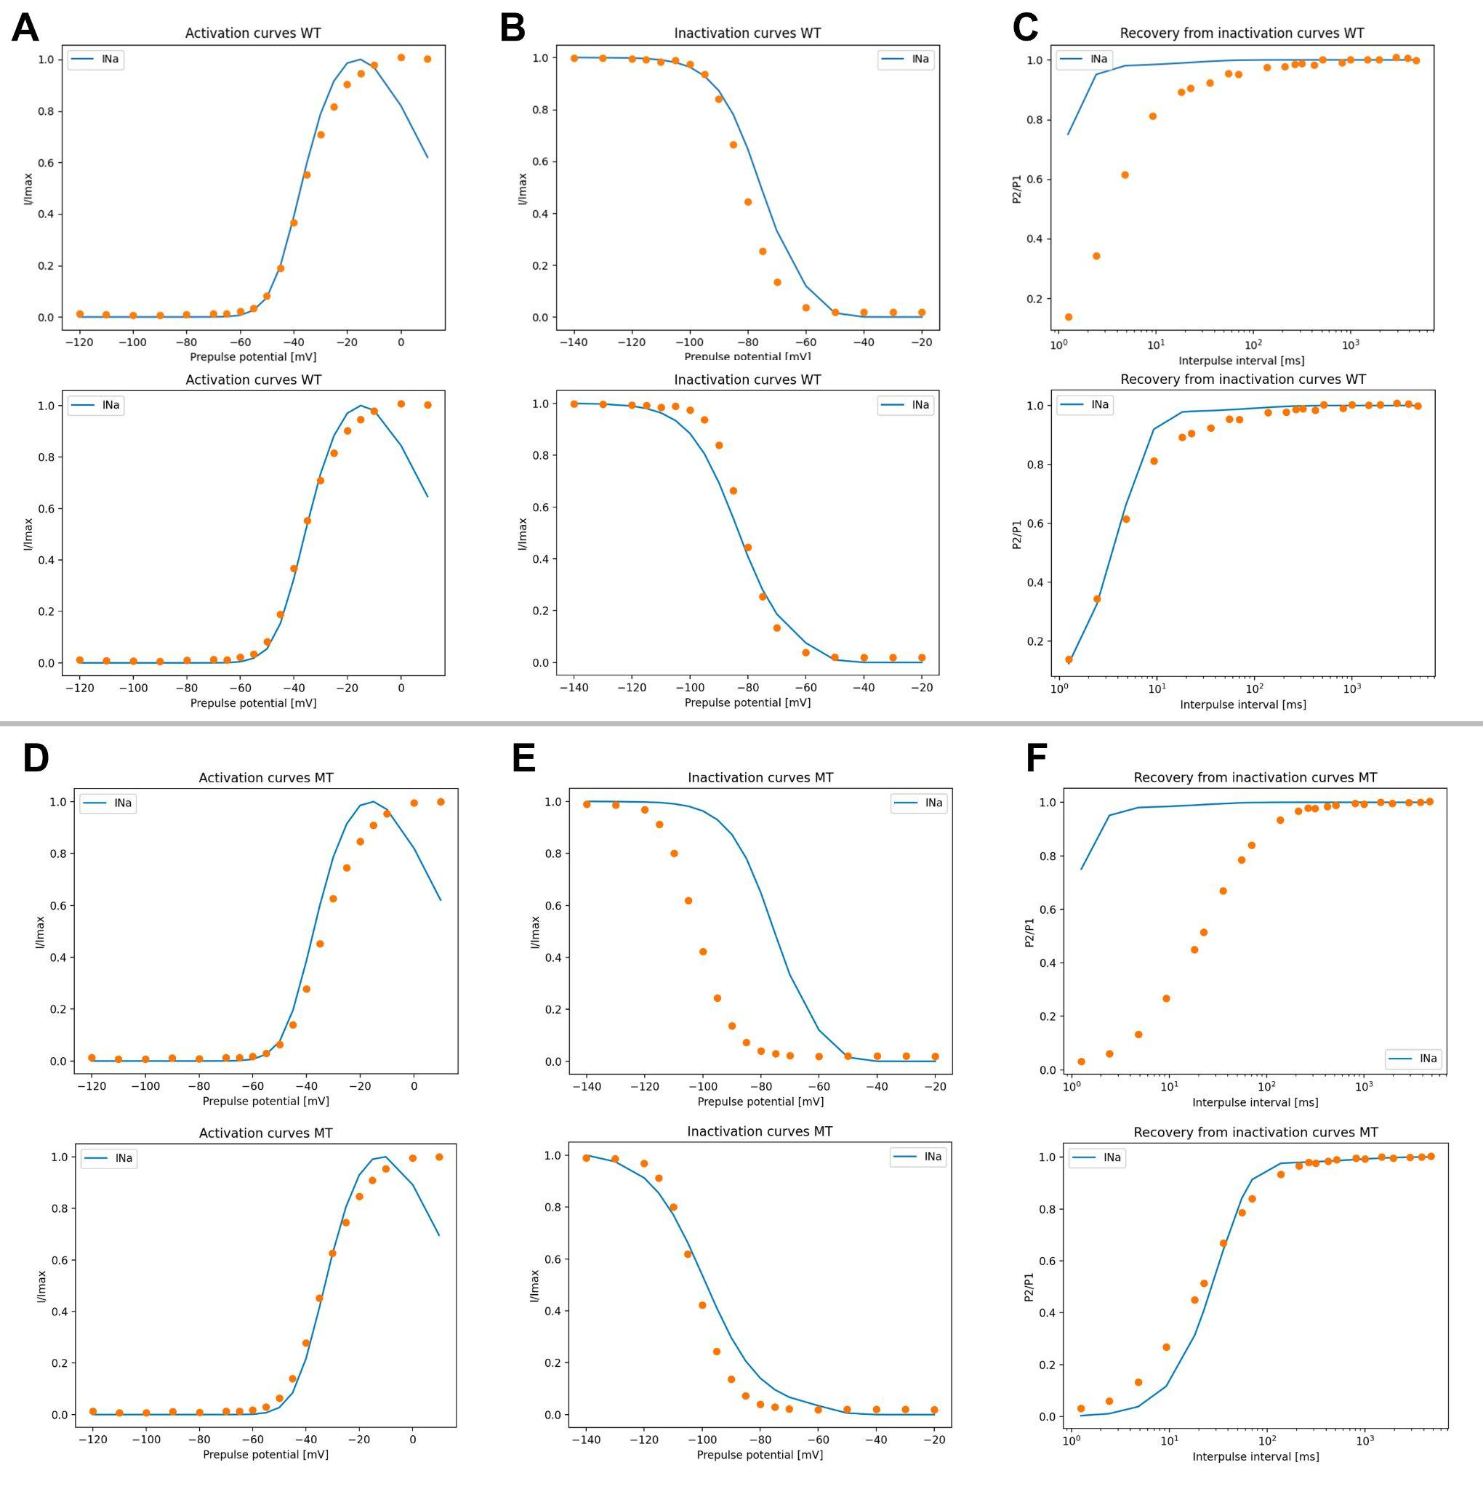

**Figure 1**: Patch-clamp protocols for model fitting to experimental data for wild type (WT) and mutant (MT) phenotype. Top panels show experimental data (orange circles) and unfitted model curves. Bottom panels show the fitted curves. Figures A, B and C show the following protocols in the WT respectively: activation, inactivation and recovery from inactivation. Figures D, E and F show the same order but for MT. All parameters were included for fitting for 100 iterations for the WT and 250 iterations for the MT.

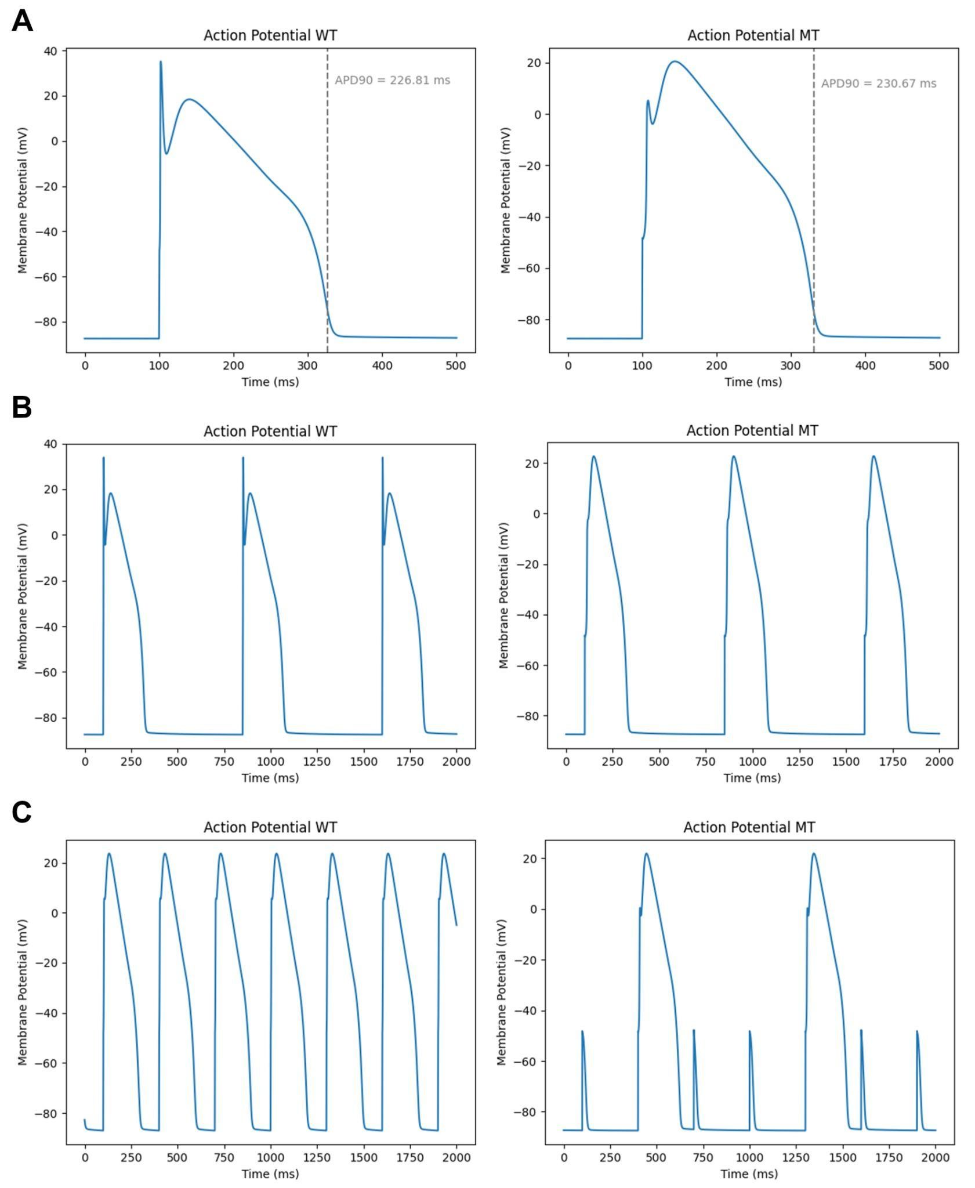

**Figure 2:** Action potential using fitted parameter sets for the WT(left) and MT(right) phenotypes. Pacing rates varied from 1000 ms (A), to 750 ms (B) and 300 ms (C).

# References

1. Vutthikraivit W, Rattanawong P, Putthapiban P, Sukhumthammarat W, Vathesatogkit P, Ngarmukos T, Thakkinstian A. Worldwide Prevalence of Brugada Syndrome: A Systematic Review and Meta-Analysis. Acta Cardiol Sin. 2018 May;34(3):267-277. doi: 10.6515/ACS.201805_34(3).20180302B.

2. Brugada R, Campuzano O, Sarquella-Brugada G, et al. Brugada Syndrome. 2005 Mar 31

[Updated 2022 Aug 25]. In: Adam MP, Feldman J, Mirzaa GM, et al., editors. GeneReviews® [Internet]. Seattle (WA): University of Washington, Seattle; 1993-2025. Available from: https://www.ncbi.nlm.nih.gov/books/NBK1517/

3. Mizusawa Y, Wilde AA. Brugada syndrome. Circ Arrhythm Electrophysiol. 2012 Jun 1;5(3):606-16. doi: 10.1161/CIRCEP.111.964577. PMID: 22715240.

4 Brugada P, Brugada R, Brugada J, Geelen P. Use of the prophylactic implantable cardioverter defibrillator for patients with normal hearts. Am J Cardiol. 1999 Mar 11;83(5B):98D-100D. doi: 10.1016/s0002-9149(98)01009-1. PMID: 10089849.

5. Decker, K. F., Heijman, J., Silva, J. R., Hund, T. J., & Rudy, Y. (2009). Properties and ionic mechanisms of action potential adaptation, restitution, and accommodation in canine epicardium. American Journal of Physiology-Heart and Circulatory Physiology, 296(4), H1017-H1026.

6. Clancy, C. E., & Rudy, Y. (2002). Na+ channel mutation that causes both Brugada and long-QT syndrome phenotypes: a simulation study of mechanism. *Circulation*, *105*(10), 1208-1213.

7. Zeng, Z., Zhou, J., Hou, Y., Liang, X., Zhang, Z., Xu, X., ... & Huang, Z. (2013). Electrophysiological characteristics of a SCN5A voltage sensors mutation R1629Q associated with Brugada syndrome. PLoS One, 8(10), e78382.

8. Dumaine R, Towbin JA, Brugada P, et al. Ionic mechanisms responsible for the electrocardiographic phenotype of the Brugada syndrome are temperature dependent. Circ Res. 1999;85:803–809.

9. Yan GX, Antzelevitch C. Cellular basis for the Brugada syndrome and other mechanisms of arrhythmogenesis associated with ST-segment elevation. Circulation. 1999;100:1660–1666.

10. Nánási, P. P., Horváth, B., Tar, F., Almássy, J., Szentandrássy, N., Jost, N., ... & Varró, A. (2021). Canine myocytes represent a good model for human ventricular cells regarding their electrophysiological properties. Pharmaceuticals, 14(8), 748.